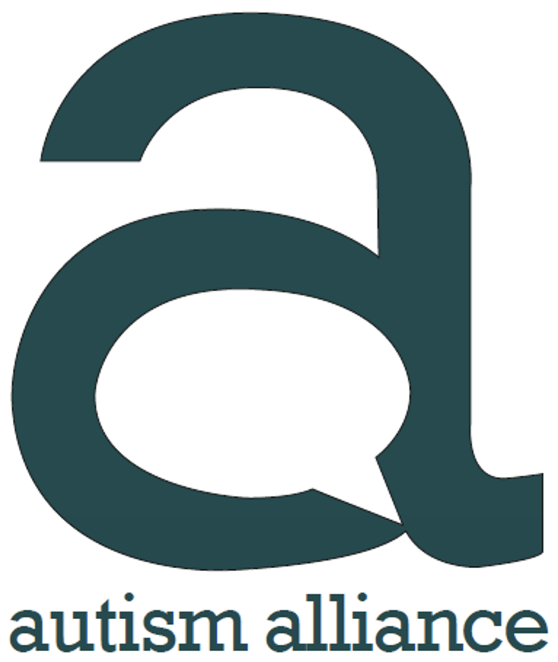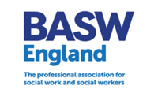
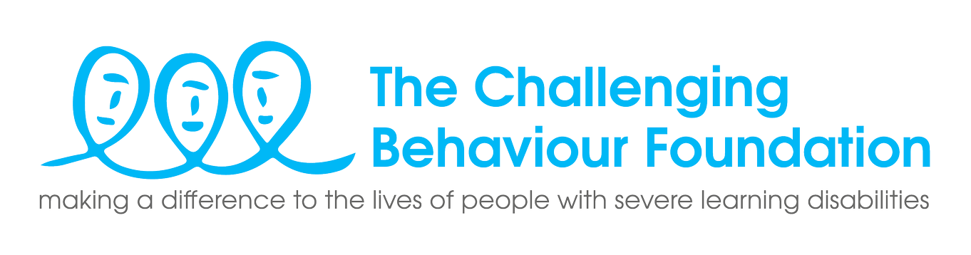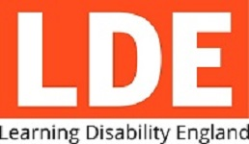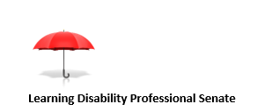
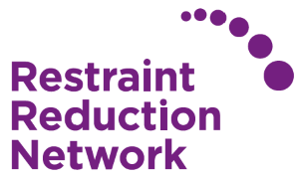
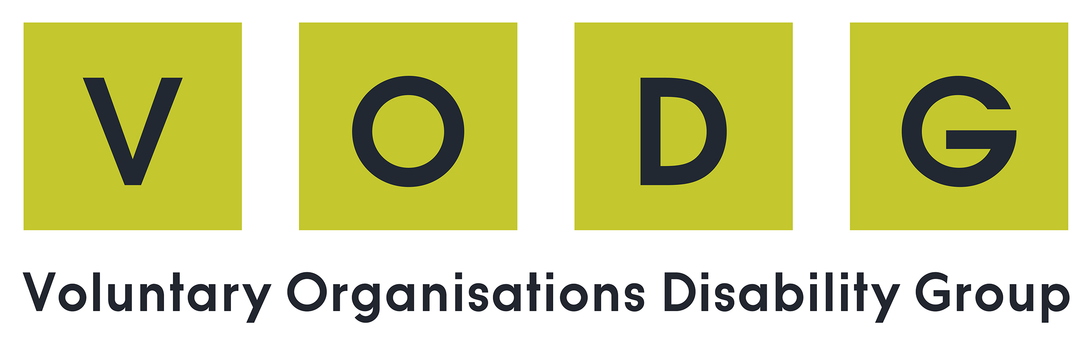

Dear Keir Starmer, Ed Davey, Carla Denyer and Adrian Ramsay,
Human Rights abuses of people with learning disabilities and autistic people
We are a group of individuals and organisations that have lived experience, provide support to children and adults with learning disabilities and autistic children and adults and their families, or support a profession that is working with individuals and families. Collectively we support, or are connected with many thousands of children and adults with learning disabilities and children and adults who are autistic, and their families.
As you will know, there have been multiple scandals exposing neglect and human rights abuses for this group of individuals for many years – all as a result of systemic failures, including lack of local community support, closed cultures, segregation, institutionalisation, purchasing inadequate and/or out of area services, and harmful restrictive practices. Numerous documentaries (e.g., Winterbourne View and Whorlton Hall) have been aired and multiple reports and investigations (e.g., the Joint Committee on Human Rights’ report on the detention of young people with a learning disability and/or autism, NHS England’s Safe and Wellbeing Reviews, and CQC’s ‘Out of Sight’ report on restraint, seclusion and segregation) have been carried out. All have identified the same underlying issues, and yet the current Government has failed to address these, despite multiple statements of “commitment” to do so.
In 2012 the Government committed to “transform care” for people with learning disabilities and autistic people who do not receive the community support they need and consequently end up in inappropriate inpatient units. These are often privately-owned, publicly funded (at a high cost), and lack oversight. The Government promised to change things so that people with a learning disability and autistic people get the support they need, when it is needed, in their own communities. However, in the 11 years since the Government made this promise:
- Targets to reduce the numbers of children and adults in inappropriate settings have been set and missed for the past 10 years.
- Over 2,000 people remain in locked settings where they stay for an average of five and a half years.
- Recent research by Mencap shows that at the current pace of change, the most recent (and revised down) target commitment to reduce inpatient numbers by 50% by March 2024 will not be achieved until November 2028 at the earliest.
- Analysis by the National Autistic Society shows that instead of going down, the number of autistic people in these hospitals has increased. In 2015, 38% of people in inpatient care were autistic – in May 2023, this figure was 65%.
- We know that the majority of these individuals could be living safely and well in their own homes; we have many examples of providers that have successfully supported people, who were previously considered to need to be in institutional settings, to live in their own homes.
- Since the abuse uncovered at Winterbourne View Hospital, abuse, harm and poor practice has continued and there have been other scandals exposing this – including Cawston Park, Whorlton Hall and Edenfield. Other reports have highlighted the continuing issues (e.g., Joint Committee on Human Rights 2019, 2020; Health and Social Care Committee, 2021; CQC (2020, 2021).
- We have seen little evidence that the new Integrated Care Boards have plans to help people to move out of hospitals or to prevent people from being admitted.
- Several reports have found that people with a learning disability and autistic people who are in inpatient settings often do not have access to high quality independent advocacy services to which they are legally entitled.
- This Government has not made human rights a priority, and people with a learning disability and autistic people continue to have their rights violated.
This national failure is due to a lack of leadership, coherent vision and a lack of investment in robust early community support. It is universally accepted that good community support and services are required to avoid inappropriate admission and to enable swift discharge from inpatient services. Yet there is no evidence of systematic incentivisation and investment in the development of community supports. The Government has instead adopted a reactive, piecemeal rather than a holistic proactive approach. This is costly – in both human and financial terms. Robust scrutiny and accountability, through regulators, is needed to ensure that the right support is being funded and that unscrupulous people and organisations are not financially benefitting at the expense of people who either cannot speak up for themselves or who are being ignored or marginalised by the beneficiaries of the status quo. These changes are achievable – we just need the political will to make them a reality.
As a society we can decide whether we provide children and adults with learning disabilities, and autistic children and adults, with the support and services, including a named social worker, which we know enables them to lead the fulfilling lives that they have a right to. We know it is possible. We need political leaders who share a vision of an inclusive and supportive society, who will champion and deliver on promises to transform care for individuals with learning disabilities and autistic people. We are looking to your party to commit to funding the right support in the right place at the right time – so that care for this group of individuals really will be transformed.
We are writing to you to ask to meet with you, so we can assist the co-development of your plans for this group of people for inclusion in your manifesto. We hope you will commit to harness the knowledge and expertise of individuals with lived experience, and other stakeholders with significant knowledge and skills to take a holistic lifelong approach. Co-produced work has started, initiated by families frustrated and angered by the Government’s inertia, in the spirit of solution-focussed collaboration. We would be happy to work with you to develop this further.
We hope you will accept this offer to work together - we can arrange a meeting with representatives from this collaborative group to discuss in detail what we can do in partnership to transform care.
We look forward to your reply.

Yours sincerely,
Clive Parry, England Director, Association for Real Change
Adam Micklethwaite, Director, Autism Alliance
Maris Stratulis, National Director, British Association of Social Workers (BASW England)
Ben Higgins, CEO, BILD
Vivien Cooper, Chief Executive, The Challenging Behaviour Foundation
Kate Chate, Scott Watkin BEM, Jack Marshall BEM and Tim Keilty, Members Representative Co-Chairs, Learning Disability England
Professor Ashok Roy, Co-Chair, Learning Disability Professional Senate
Caroline Stevens, Chief Executive, National Autistic Society
Restraint Reduction Network
Julie Newcombe, Co-Founder, Rightful Lives
Speakup Self Advocacy
Dr Rhidian Hughes, Chief Executive, Voluntary Organisations Disability Group (VODG)
Jonathan Senker, Chief Executive, VoiceAbility

